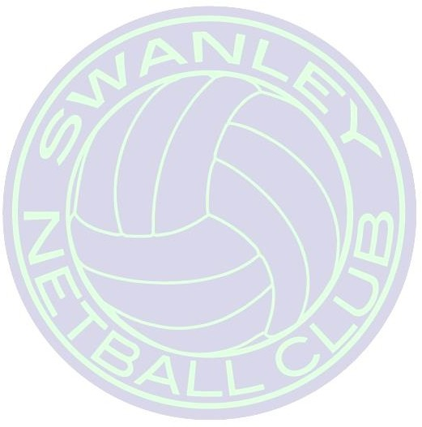
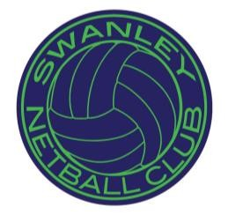
Swanley Netball Club
Operational Risk Assessment – Netball

Activity: | Netball
Assessment Date: | 30th March 2021
Review Date: | 21st June 20201
Name and Role of Assessor: | Christine Lander Secretary and Janet Hills Head Coach
Who Might Be At Risk: | Coaches, Officials, Participants and members of the public

Hazard Identified | Potential Harm | Severity | Likelihood | Risk Score | Risk Category | Risk Management/Control Measures
Injury | Cuts, Fractures, Sprains and Bruises | 2 | 3 | 5 | Medium | - Lead Coaches/Captains to make sure that First aid kits are present at all time  - All Lead Coaches are Emergency First aid trained  - Ensure any injuries/incidents are reported to the Lead Coach so all are aware  - Ensure all participants wear appropriate footwear and clothing  - Ensure all players jewellery is removed
Court Conditions | injuries (Cuts, fractures, sprains and bruises) sustained from  unsafe surface | 3 | 2 | 5 | Medium | - Lead Coaches/Players to check playing surface before and during play  - Report any faults or concerns with surface to Secretary/Committee member. If surface is unsafe to use do not proceed with planned activity
Medical Conditions | Participants with medical conditions eg  Asthma or Epilepsy | 4 | 2 | 6 | Medium | - Records kept of any members with existing medical conditions that Lead Coaches should be made aware of  - Participants to seek professional medical attention if unsure
Inexperienced Coaches | Potential injury to participants from misuse of equipment | 1 | 2 | 3 | Low | - Only qualified Level 2 Coaches to lead training sessions  - Level 1 or untrained coaches will have an assisting Level 2 coach available at all times

Swanley Netball Club

Collisions with surrounding people | Cuts, fractures and bruises | 1 | 3 | 3 | Low | - Encourage good communication between players in matches, although some contact is inevitable due to the nature of the sport  - Ensure any injuries/incidents are reported to the Leaf Coach so the relevant people are aware
Conflict with equipment | Potential injury to participants colliding with equipment | 2 | 2 | 4 | Low | - Lead Coaches to ensure all equipment is fit for purpose before and during play eg Netball Posts, running ladders etc  - Participants are responsible for wearing appropriate footwear and clothing  - All unnecessary equipment is removed to a safe distance from the court  - Report any damage to equipment to Lead Coach, who will withdraw equipment from use if found to be unsafe.
Aggression between players | Potential injuries (cuts, fractures and bruises) | 2 | 2 | 4 | Low | - Ensure players understand and sign SNC’s Code of Conduct governing such behaviour  - Disciplinary action should be taken if the Codes of Conduct are broken  - Ensure any injuries/incidents are reported to the Lead Coach so the relevant people are made aware
Ignorance of Rules | Potential injuries (Cuts,  fractures and bruises) | 2 | 2 | 4 | Low | - All players must adhere to the rules of the game  - Qualified coach/umpire should be on hand to assist with any questions/queries on the game rules

Swanley Netball Club

General Risk Management/Control Measurements | - Lead Coaches/Captains must ensure that First aid kits are present at facility at all timesto do frequent checks of facility  - Lead Coaches/Umpires to ensure that players have removed all jewellery before starting a session  - Lead Coaches/Players to do frequent checks on facilities and equipment  - Participants to ensure they are in appropriate clothing and footwear whilst training/playing and/or spectating

Risk Assessment Signed by Assessing Officer: _

Key to Risk Ratings:
1. Minor | Causing minor injuries
2. Low | Causing significant injuries eg sprains, bruises, lacerations
3. Medium | Causing temporary disability eg fractures
4. High | Causing permanent disability eg loss of limb, sight or hearing
5. Major | Causing death to one or more people

Likelihood Rating:
1. Improbable | Loss, accident or illness could occur under freak conditions. The situation is well managed and all reasonable precautions have been taken
2. Low | The situation is generally well managed however occasional lapses could occur. This also applies to situations where people are required to behave safely in order to protect themselves but are well trained
3. Medium | Insufficient or substandard controls in place. Loss is unlikely during normal operation however may occur in emergencies or non-routine conditions
4. High | Serious failures in management controls. The effects of human behaviour or other factors could cause an accident but is unlikely without this additional factor eg ladder not secured properly, oil spilled on floor
5. Almost Certain | Absence of any management controls. If conditions remain unchanged there is almost a 100% certainty that an accident will happen eg broken rung on a  ladder, untrained personnel

Risk Rating:
Risk Score | Risk Category
1 – 4 | Low
5 – 7 | Medium
8 – 19 | High

